08/07/2017

Name: Virti Bipin Sanghavi ID: 1001504428

Name: Dhinesh Kumar Sivakumaran ID: 1001393555

**Flow:**

Start 🡪Save input files as csv 🡪 Import data into tables using MySQL workbench 🡪 Execute script/program to create project and department document from MySQL and also insert it into MongoDB 🡪 Verify imported data using Queries 🡪Finish

**Data Import:**

**1)employee**

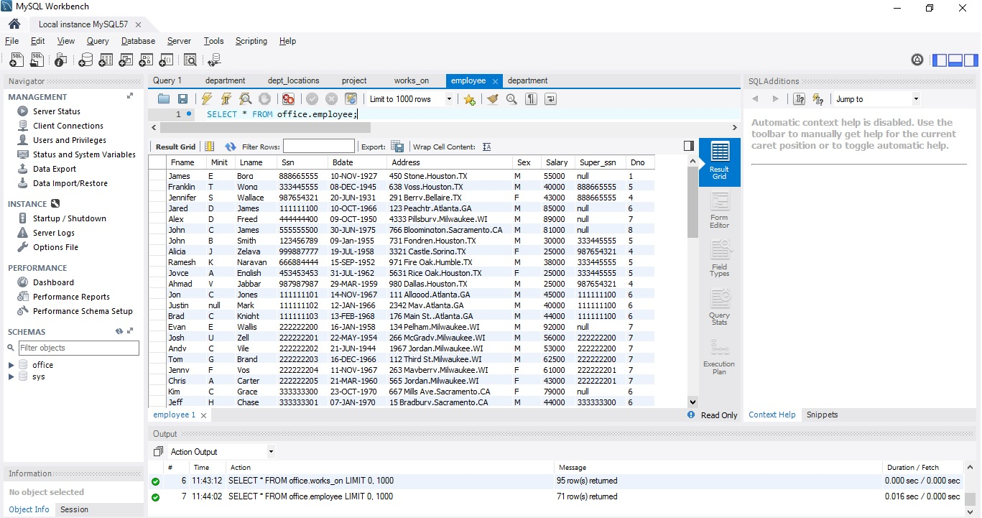

**2)department**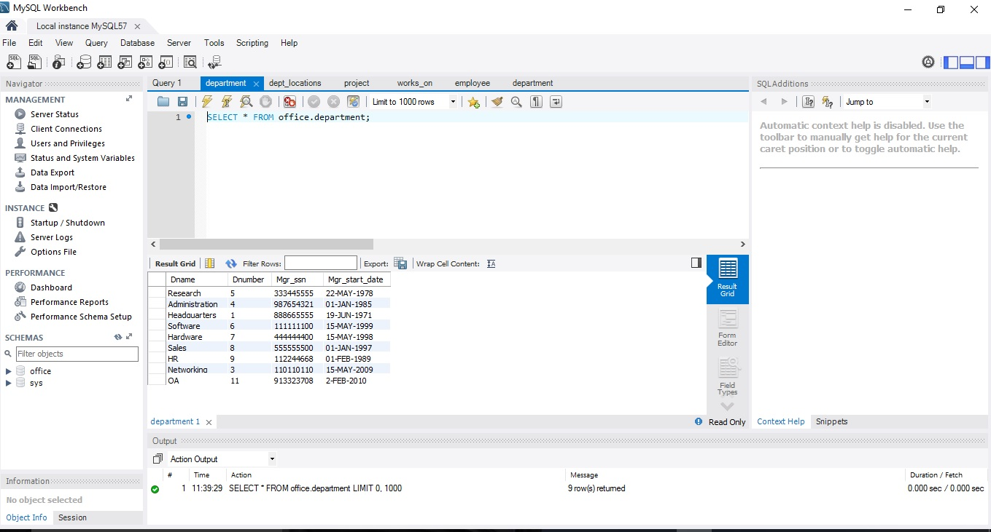

**3)works_on**

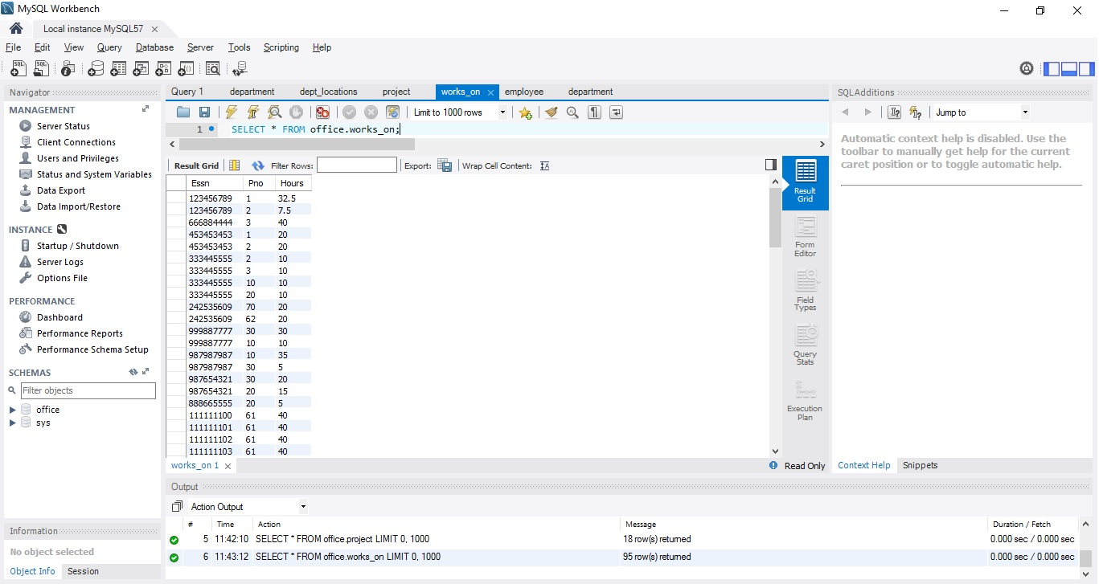

**4) dept_locations**

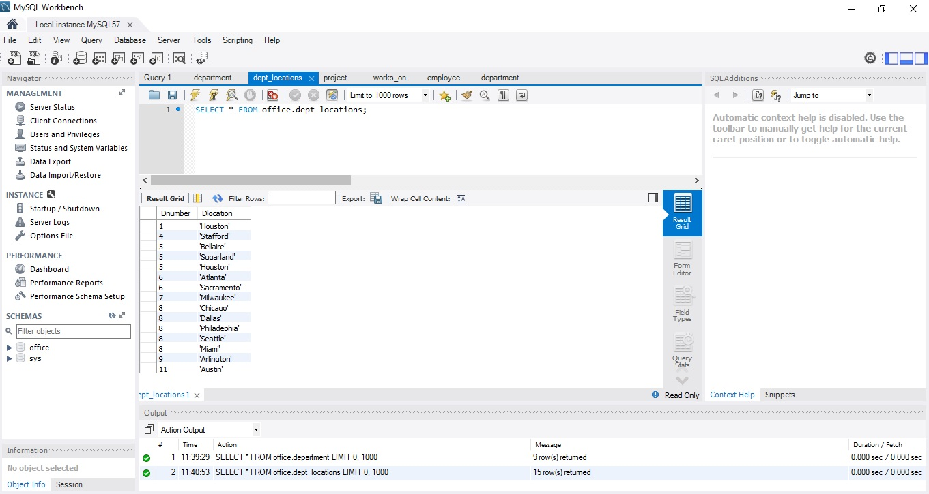

**5) project**

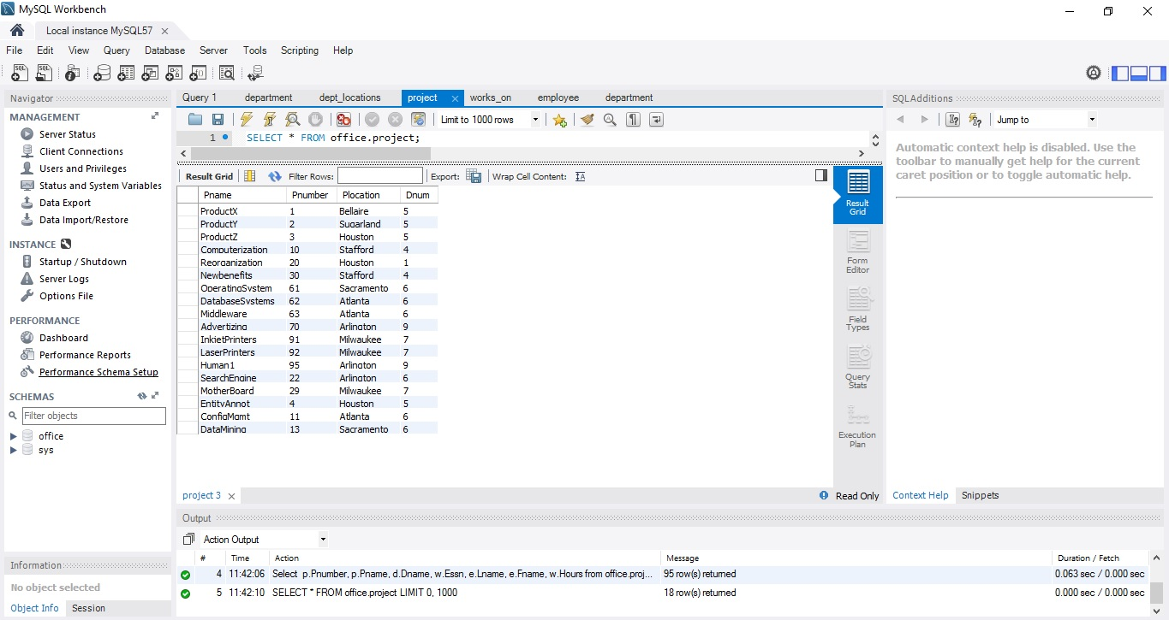

**Installation of MongoDB**

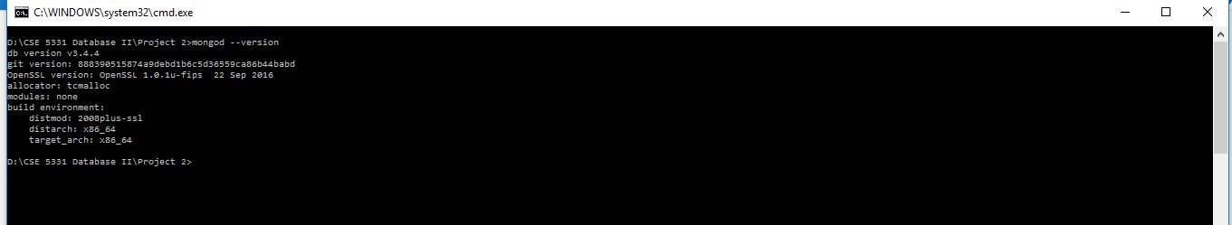

**MongoDB Server Started**

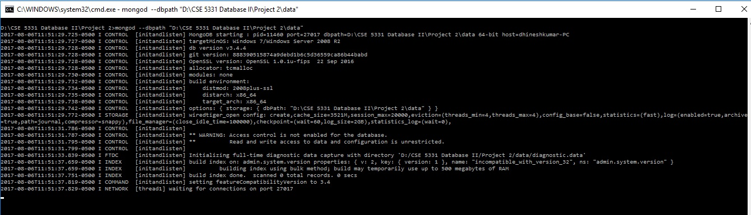

**Simple Document of MongoDB creation**

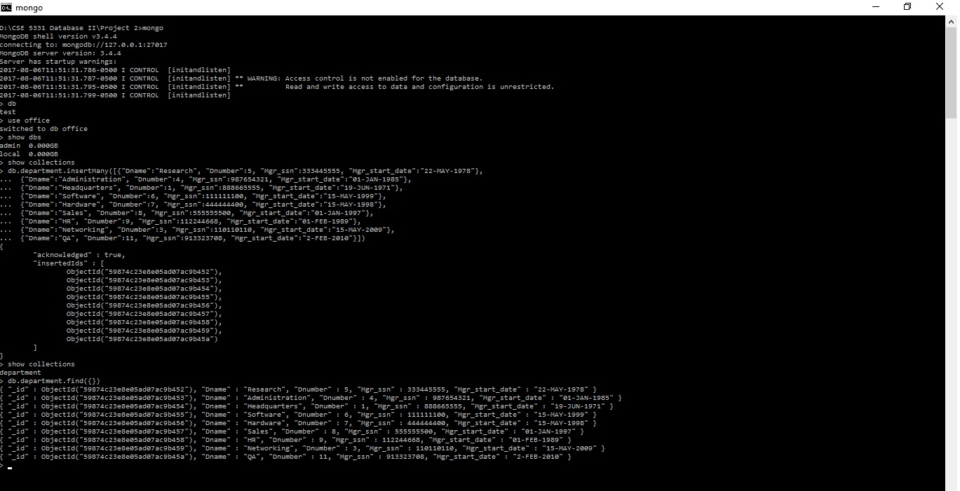

**How do you convert Relational Data into Mongodb?**

**Project:-**

**<Query explained in plain English>**

Select p.Pnumber, p.Pname, d.Dname, w.Essn, e.Lname, e.Fname, w.Hours

from office.project as p INNER JOIN office.department as d on d.Dnumber = p.Dnum

INNER JOIN (office.works_on as w INNER JOIN office.employee as e on e.Ssn = w.Essn) on w.Pno = p.Pnumber

order by p.Pnumber

**Department:-**

**<Query explained in plain English>**

SELECT d.Dname, e.Lname, l.Dlocation

FROM office.department as d INNER JOIN office.employee as e on d.Mgr_ssn = e.Ssn

INNER JOIN office.dept_locations as l on d.Dnumber = l.Dnumber

order by d.Dname;

**Pseudo Code**:

1.Connect to MySQL and Mongo DB

2.Execute query to retrieve department and project table

#In case of project data

Select p.Pnumber, p.Pname, d.Dname, w.Essn, e.Lname, e.Fname, w.Hours

from office.project as p INNER JOIN office.department as d on d.Dnumber = p.Dnum

INNER JOIN (office.works_on as w INNER JOIN office.employee as e on e.Ssn = w.Essn) on w.Pno = p.Pnumber

order by p.Pnumber

#In case of department data

SELECT d.Dname, e.Lname, l.Dlocation

FROM office.department as d INNER JOIN office.employee as e on d.Mgr_ssn = e.Ssn

INNER JOIN office.dept_locations as l on d.Dnumber = l.Dnumber

order by d.Dname;

3.Loop thorough all result rows

#In case of project data

Group all records with same Pname, Pnumber, Dname and include their employees’ details as array of object with Essn, Fname, Lname attributes

#In case of department data

Group all records with same Dname, Manager Lname and include their location details as array of objects with Dlocation attributes.

4.Insert the output json object into mongo DB as Project and Department Document

5.Disconnect from MySQL and MongoDB

**Result for the Project Data:**

1. The PROJECT document will include the following data: Pnumber, Pname, Dname (of the controlling department), plus a list of the employees that work on the project {employees: Lname, Fname, Hours}.

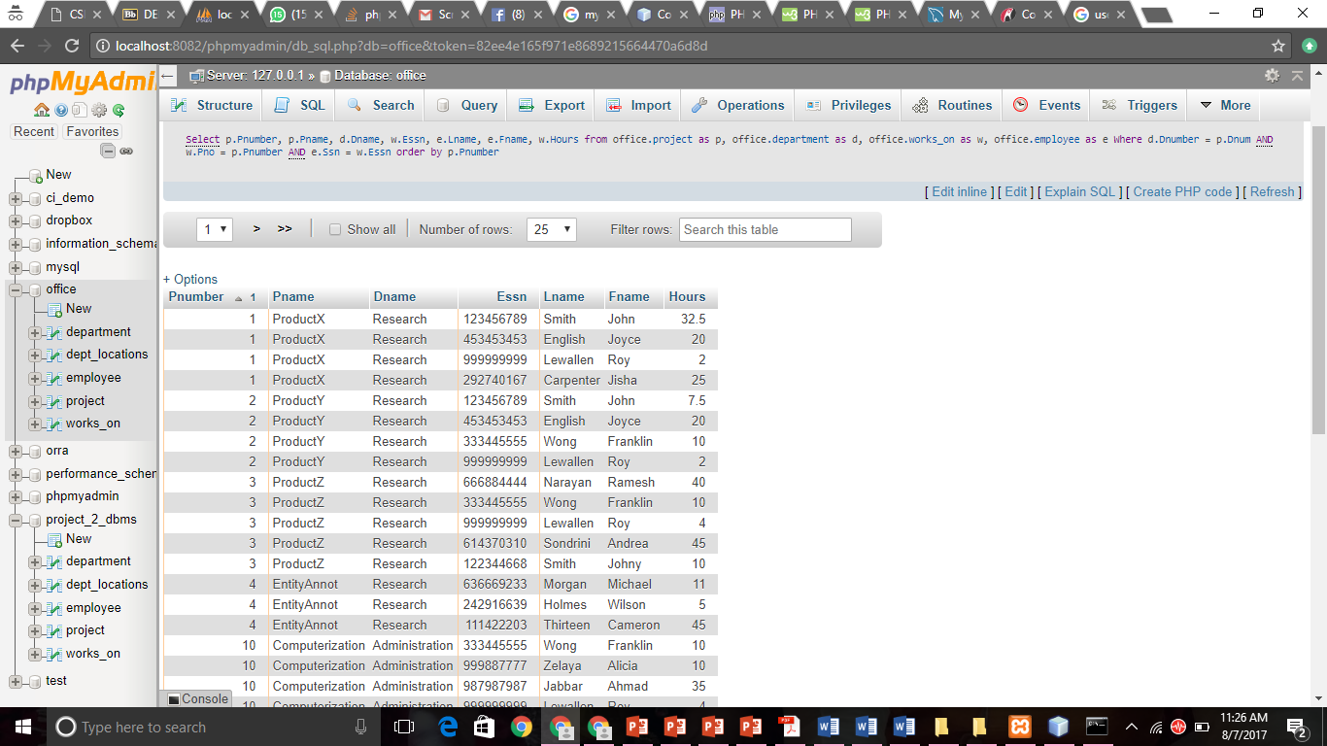

**Result for the Department Data:**

1. The DEPARTMENT document will include the following data: Dname, the department manager’s Lname, and a list of the locations of the department {locations: Dlocation}.

**Here we have been using grouping by attribute and group by Department name(Dname).**

Here, the department name stays constant, we make an array of the list of Last names of the manager of the department and the location he is working on.

